Dear Parents and Carers, 12th April 2024

We have welcomed back our students to the summer term and they have come back fabulously. Their conduct, attention to key messages and politeness have been excellent. The Easter break has refreshed and revitalised the students, particularly important for our examination year groups who begin exams in a few weeks time.

Thank you so much for your support in ensuring that our students wear the appropriate uniform as per our expectations and standards. We have explained to students the importance of uniform in creating equality and inclusiveness in our school. There has been a real focus on ensuring that socks are ankle length and skirt lengths are just above the knee as part of our safeguarding and I would like to thank parents and carers for sourcing uniform as per our policy. This is something that we are placing a large focus on this term as we continue our drive on raising expectations. It has been good to see so many students seeing the importance of the details setting the tone for other aspects of the school experience. Please do contact your son/daughters head of year if there are any issues with uniform - we are more than happy to support where needed.

This week saw our houses launched to students with the first inter-house competitions in PE. It has been a pleasure seeing students eager to get house points and rise to the challenge of healthy competition amongst each other. Needless to say, the staff have joined in the competitiveness too with their allocated houses. Our student council have been excellent in shaping the entire house system democratically choosing names, mascots and a range of competitions over this term to build up house point totals.

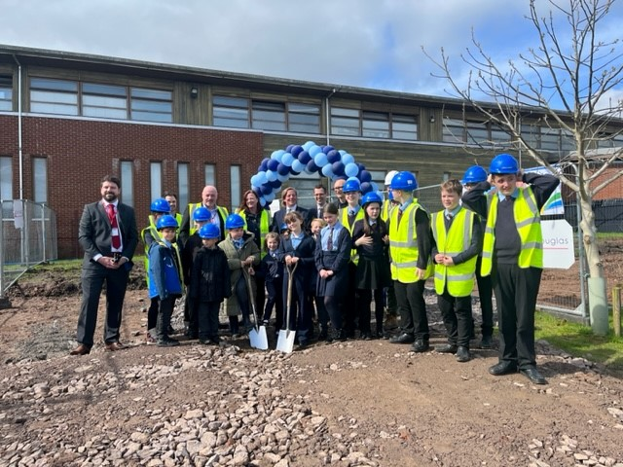
Our student council also were ambassadors for the school in the groundbreaking ceremony. This saw representatives from the feeder primary schools, Rubery library, district councillors, St Chads Church, the Department for Education, Tilbury Douglas, school governors and trustees come together to celebrate the incredible opportunities that the new build will bring to our students and wonderful community. Our school council joined up with Lickey Hills Pupil Parliament and enjoyed wearing the hard hats and high vis jackets to take part in the ceremony. Thank you for those who joined the celebrations. The ceremony was summarised wonderfully by Guy Shears our CEO who said that some new build schools are excellent buildings, but lacklustre inside. We firmly believe that the Waseley improvement means that the new build will match the incredible staff and students already inside. Thank you for the student council who were exceptional at networking with our community partners, including some lobbying of the DFE for more money for Waseley! Great job!

Academically, the Year 12 students had a successful Parents Evening yesterday and their progress is looking strong as a year group. We look forward to updating Year 7 on their strong start to Waseley next Thursday at their Parents Evening. Monday was the deadline for Year 9 Options choices, please submit these asap if you haven't done so already.

As part of our drive to continually improve Waseley, we value the feedback from parents and carers. Thank you for those who have already completed the Spring Term feedback survey. Please could I request that if you haven't already responded that you use the link below.

https://forms.office.com/Pages/ResponsePage.aspx?id=UTeH7weIjkS2mO4DGypXkrSGiTWVxVNNlpn2nYqOtDFUMkNLRlNHTE42N0VWRUpQOE4yREpMU002NC4u

Thank you for your continued support.

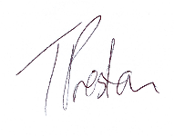
Yours sincerely

Mr Preston
Head of School

