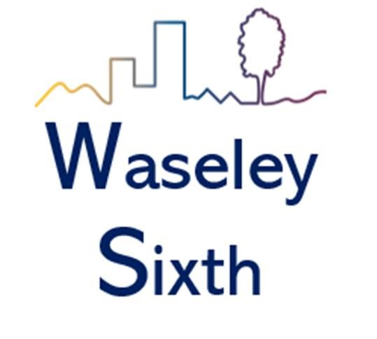

Level 3 Health and Social Care
Bridging Course

HSC Task 1
When you start the course in September we will begin by looking at development across the human lifespan.
In preparation for this create a summary of the key theorists below:
- Piaget’s model of how children’s logic and reasoning develops – stages of cognitive development, the development of schemas, his tests of conservation, egocentrism and how his model may explain children’s thoughts and actions
- Chomsky’s model in relation to how children acquire language – Language Acquisition Device (LAD), the concept of a critical period during which children may learn language, which may explain how children seem to instinctively gain language.

HSC Task 2
The first year of the course is focused on a range of topics, mainly human development and meeting individual needs. In order for you to develop your knowledge we suggest you read, watch and listen to a range of materials to support you. Useful links below, choose two and summarise them, what have you learned? What would you like to explore further and why?
Watch YouTube:
How a baby develops during pregnancy; https://www.youtube.com/watch?v=h82ltr84_Yg
Bupa Health. Lifespan Development: Late Adulthood Piaget's Theory of Cognitive Development; https://www.youtube.com/watch?v=fPS23DIqHPU The Attachment Theory: How Childhood Affects Life https://www.youtube.com/watch?v=WjOowWxOXCg&t=33s
Websites:
https://www.prospects.ac.uk/ - research roles and responsibilities of the following health and social care workers: Nurse, Social Worker, Health Care Assistants, Midwives, Doctors & Youth Workers.
https://www.nhs.uk/ - research various illnesses: cystic fibrosis, brittle bone disease, Down’s syndrome, Diabetes, Osteoarthritis & Cardiovascular Disease.
Online News articles:
The Guardian:
‘More than 8 million people in England living in unsuitable housing’ https://www.theguardian.com/society/2019/sep/23/people-england-livingunsuitable-housing
BBC News:
‘Housing crisis affects estimated 8.4 million in England’ https://www.bbc.co.uk/news/uk-49787913

HSC Task 3
Health and Social Care is built on principles of equality, person centred care and personalisation. There are times when things go wrong. Write an short essay, no more than two sides of A4, which gives examples of bad/poor practice that has had significant changes on current practice.
Examples – Victoria Climbie death and Winterbourne Care Home

HSC Task 4
It is important to make the public realise about the issues which are prevailing in society relating to health and social care. One way in which public awareness is raised about health and social care in general and issues that exist within the health and social care sector is through the media. Watch one of the below and consider the following:
- What issues are being raised?
- Is it informative/helpful and why?
- How effective is the programme in raising public awareness about H&SC/Issues?



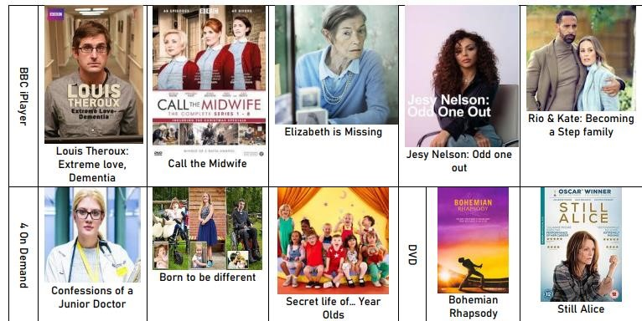

Task 5:
Chose a professional from the following:
- Midwife
- Paramedic
- Paediatric nurse
- Nutritionist
- Physiotherapist

You could choose your own idea from health and social care roles if you prefer.
Create a fact file for your chosen job role. You could include:
- A day in the life of... • Average pay
- General roles and responsibilities • Where they work
- Routes into the role/ qualifications required • Who they work with
- Skills & qualities

Word | Definition
Development
Growth

Self esteem
Self-concept

Holistic approach
Course essentials:
In September please come prepared with a ring binder and notepad as well as dividers for the different topics we will be covering. Your class notes will be checked during our quality assurance process, you will also want access to them when writing your coursework - organisation is essential.
Link to the Pearson course webpage:
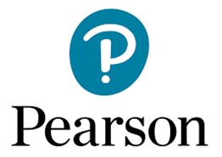
BTEC Nationals | Health and Social Care (2016) | Pearson qualifications
Any questions email:
ZHarley@waseleyhills.worcs.sch.uk

