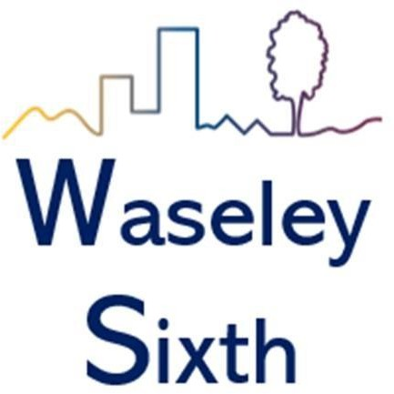

A Level History Bridging Course

AQA A Level History Developing as a Historian

Paper 1 –
Breadth Study

1C The Tudors: England, 1485–1603
Paper 2 – Depth Study

2O Democracy and Nazism: Germany, 1918–
1945

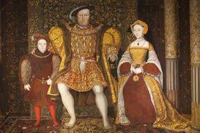
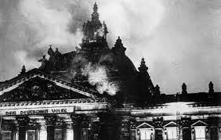

A Level History

These tasks are designed to give you a taster of what A Level History at Waseley will be like. They will introduce you to the topics that we study and give you a foundation in your knowledge and understanding in preparation for 6th Form. If you have any questions, please email either Mrs Dumycz or Mrs Jones for help.
sdumycz@waseleyhills.worcs.sch.uk for 1C
emjones@waseleyhills.worcs.sch.uk for 2O

We follow the AQA A Level options 1C and 2O. You can find out more about these here: https://www.aqa.org.uk/subjects/history/as-and-a-level/history-7041-7042

These units are chosen to tie into GCSE, where we will have studied Early Elizabethan England and Weimar and Nazi Germany. However, you do not need to have studied History a GCSE to join us in 6th Form.

Developing as a Historian means being able to see beyond facts, figures and dates. It means being able to analyse cause and consequence, understand change and continuity, discuss significance and analyse impact. It is about being able to understand timelines and timeframes, whilst also appreciating that the events we study are happening to, and for, (mainly) ordinary people. Through this we can develop a deeper knowledge and understanding of how our world has come to be, and of how it works the way it does.

1C The Tudors: England, 1485–1603

This option allows students to study in breadth issues of change, continuity, cause and consequence in this period through the following key questions:
- How effectively did the Tudors restore and develop the powers of the monarchy?
- In what ways and how effectively was England governed during this period?
- How did relations with foreign powers change and how was the succession secured?
- How did English society and economy change and with what effects?
- How far did intellectual and religious ideas change and develop and with what effects?
- How important was the role of key individuals and groups and how were they affected by developments?

Your teachers will encourage you to read heavily. This includes fiction as well as non-fiction.

Non-fiction:
You can often find these second hand online, or in online libraries. There are copies of some in school, and the list does include the key text that you will be given in September.

C Lee, Britain, 1483-1529, Nelson Thornes, 2008

R Carpenter, The Church in England and the Struggle for Supremacy, 1529-1547, Nelson
Thornes, 2009

M Tillbrook, The Triumph of Elizabethan Britain 1547-1603, Nelson Thornes, 2009

I Dawson, The Tudor Century, Nelson Thornes, 1993

C Carpenter, The Wars of the Roses, CUP, 1997

E Duffy, The Stripping of the Altars, Yale, 1992

D Cook, Sixteenth Century England Documents and Debates, Macmillan, 1980

N Fellows, Disorder and Rebellion in Tudor England, Hodder, 2009

Fiction:
Wolf Hall, Bring Up the Bodies, The Mirror and the Light by Hilary Mantel. A remarkable series following the rise and fall of Thomas Cromwell. Wolf Hall was critically acclaimed as one of the best historical novels of all time. They are weighty books, but worth it!
The Concubine by Norah Lofts

Six Tudor Queens series by Alison Weir

The King’s Mother by Annie Garthwaite

The Shardlake Series by CJ Sansom. A series for those who love some crime and drama with their history!

Podcasts and documentaries:
The Henry VIII: The Mind of a Tyrant documentary series by David Starkey is a MUST. You can find them all on YouTube.
The Boleyns: A Scandalous Family
The Boleyns: A Scandalous Family - BBC iPlayer
Six Wives with Lucy Worsley
Six Wives with Lucy Worsley - BBC iPlayer
Not Just the Tudors by Prof Suzanna Liscombe. BBC Sounds. A fantastic series exploring what the world was like for the Tudors.
BBC Sounds - Not Just the Tudors - Available Episodes
Talking Tudors hosted by Natalie Grueninger
https://feed.podbean.com/talkingtudors/feed.xml

Activities
- Complete a family tree of the Tudors from Henry VII to Elizabeth I. Include spouses, siblings and cousins.
- Complete the introductory learning on Seneca (you will need to set up an account, and choose the free option!)
https://app.senecalearning.com/dashboard/courses/add?Price=Free&Price=Premium&Subject=History
- Describe the key events, key individuals and the consequences of the Wars of the Roses.
- Read one of the novels (or another suitable novel set in the Tudor time period) and summarise how the England, and its people are represented. Email your teacher if you need advice

Democracy and Nazism: Germany, 1918–1945
This option provides for the study in depth of a period of German history during which a newly developed democratic form of government gave way to a dictatorial Nazi regime. It explores political concepts such as 'right' and 'left', nationalism and liberalism as well as ideological concepts such as racialism, anti-Semitism and Social Darwinism. It also encourages reflection on how governments work and the problems of democratic states as well as consideration of what creates and sustains a dictatorship.
As with Paper 1, it is vital to be aware of the ‘map’ of this unit. The best place to begin is by creating your own map of Germany for 3 key dates: 1919; 1939 and 1945. You need to be aware of the expansion and collapse of the Third Reich. Use the map below as a guide. You can easily find one online with simple google search.

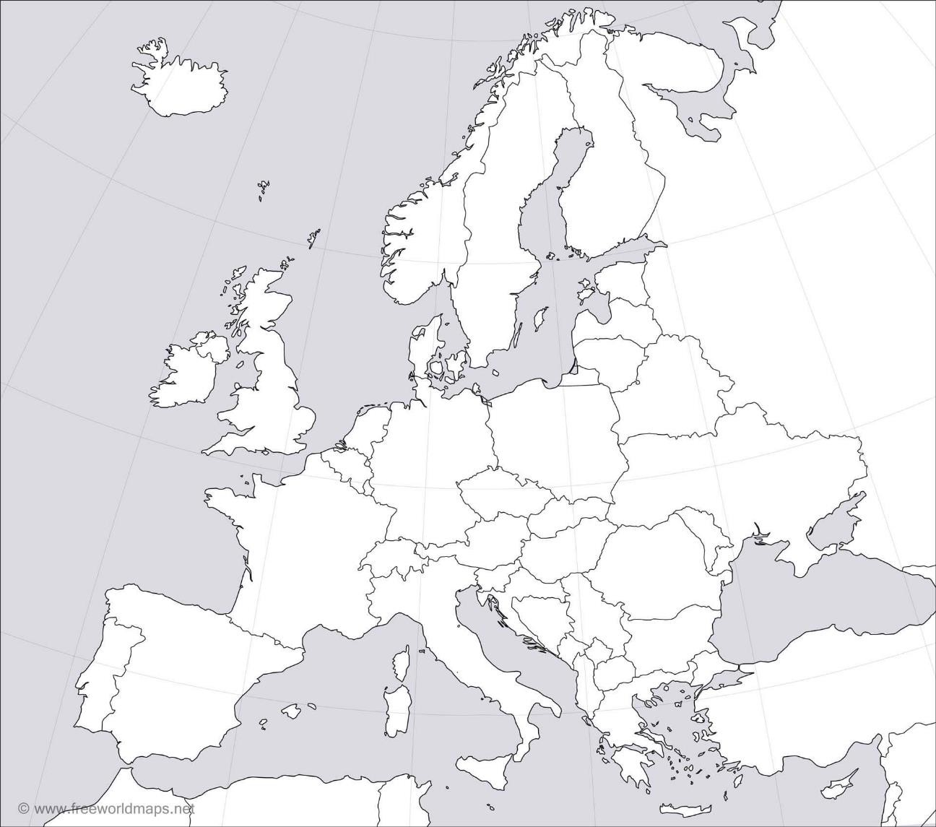

Your teachers will encourage you to read heavily. This includes fiction as well as non-fiction.
Non-fiction: You can often find these second hand online, or in online libraries. There are copies of some in school, and the list does include the key text that you will be given in September.
G Layton, Access to History: From Kaiser to Fuhrer: Germany 1900-1945

M Collier, P Pedley, Heinemann Advanced History: Germany 1919-45
R Whitfield, Democracy and Nazism: Germany 1918-1945
A McElligott, Weimar Germany (Short Oxford History of Germany)
L Rees, The Nazis: A Warning from History
L Smith, Forgotten Voices of The Holocaust: True Stories of Survival from Men, Women and Children Who Were There

Fiction:
The Bernie Gunther series by Philip Kerr
Alone in Berlin by Hans Fallada – a book about two people who try to resist the Nazis.
The 20th of July by Hans Hellmut Kirst - shows the Third Reich through the eyes of an ordinary, reluctant soldier.
Winter: A Berlin Family 1899 – 1945 by Len Deighton – a story of a father and his two sons. Read as flashbacks from both working as lawyers in the Nuremberg Trials. One son follows the doctrines of the Nazi Party, the other is exiled to America.

Podcasts and Documentaries:
Auschwitz - The Nazis and The Final Solution, [DVD] Downfall (1 Disc Edition), [DVD]
Hitler: The Rise of Evil, (2003), [DVD]
Schindler's List - 20th Anniversary Edition, [DVD], [1993] The Nazis - A Warning From History, [DVD]
The Relief Of Belsen, [DVD]
Babylon Berlin is the largest ever German TV drama. Currently all series are on Netflix and Series 1 is on Sky.
The Last Days of Sophie Scholl a film that uses the testimony of one of the leaders of the students White Rose Movement executed for opposition to Hitler’s rule.
Defiance is the story of the Bielski family and their life during WWII (this is available on Netflix)
WWII in Colour a useful guide to the Second World War, in particular episodes 2,4,7,8 and 12 (this is available on Netflix)
The Weimar Republic: Germany's First Democracy https://www.youtube.com/watch?v=XwI6o2npqOY Germany: Memories of a Nation. BBC podcasts

Heil Hitler!: Confessions of A Hitler Youth (HBO Movie) https://www.youtube.com/watch?v=JJ6umV7CVY8&feature=emb_logo

Activities
- Complete the map task at the top of this section.
- Complete the introductory learning on Seneca (you will need to set up an account, but it is free)
https://app.senecalearning.com/classroom/course/0aaaa356-ba64-4f20-80a8- d8bbce9981dc/section/d6352e20-85ee-4664-ad26-515d860fb916/session
- Describe the social, political, and economic state of Germany in 1918.
- Read one of the novels (or another suitable novel set in Germany during our time period) and summarise how Germany, and its people are represented. Email your teacher if you need advice.

