A Level English Literature
Bridging Course

A Level English Literature Bridging Course

Welcome to A Level English Literature. This pack of tasks has been designed to bridge your core knowledge from GCSE Literature to A Level Literature, growing your understanding and developing your ability to critique texts.

War Poetry was a point of study in your GCSE Power and Conflict Anthology. You will be seamlessly linking this knowledge to the A Level component titled: WWI and its aftermath. In this component, you will be studying an anthology of WWI poems, a play called ‘Journey’s End’ written by R. C. Sheriff and a novel called ‘The First Casualty’ written by Ben Elton.

__________

Task 1 – 45mins:

Read the article ‘Changing lives: gender expectations and roles during and after World War One’.

https://www.bl.uk/world-war-one/articles/changing-lives-gender-expectations

- Make some notes about how this article allows you to consider the effect of war on men and women.
- Consider your study of ‘Bayonet Charge’ by Ted Hughes at GCSE level and answer these questions:

- In what way could the soldier in ‘Bayonet Charge’ have been pressured into being a solider?
- How were the expectations of masculinity unfair?
- How much did society change for men when they returned home from war? How could this have impacted them?

__________

Task 2 – 45mins:

Read the article ‘There is more to war poetry than mud, wire and slaughter’ by Andrew Motion:

https://www.theguardian.com/books/2016/jul/09/andrew-motion-definition-war-poetry-widen-not-just-first-world-war

Pick out three points to share. These could be ideas you find interesting, that you want to question or challenge.

__________

Task 3 – 1 hour 30 minutes:

Watch the documentary Trech Warfare – Apocalypse World War One:

Trench Warfare | Apocalypse Word War I - Episode 2 - DocsOnline

Answer these questions:

- How did such a cruel and far-reaching conflict occur?
- Why did the warring parties resort to trench warfare?
- How did humankind endure this atrocity for four long years?
- Could the sacrifice of an entire generation have been avoided?

__________

Task 4 – 45 mins:

How does the documentary link to the ideas that Wilfred Owen explore in ‘Exposure’?

Exposure
BY WILFRED OWEN

Our brains ache, in the merciless iced east winds that knive us . . .
Wearied we keep awake because the night is silent . . .
Low drooping flares confuse our memory of the salient . . .
Worried by silence, sentries whisper, curious, nervous,
But nothing happens.

Watching, we hear the mad gusts tugging on the wire,
Like twitching agonies of men among its brambles.
Northward, incessantly, the flickering gunnery rumbles,
Far off, like a dull rumour of some other war.
What are we doing here?

The poignant misery of dawn begins to grow . . .
We only know war lasts, rain soaks, and clouds sag stormy.
Dawn massing in the east her melancholy army
Attacks once more in ranks on shivering ranks of grey,
But nothing happens.

Sudden successive flights of bullets streak the silence.
Less deadly than the air that shudders black with snow,
With sidelong flowing flakes that flock, pause, and renew,
We watch them wandering up and down the wind's nonchalance,
But nothing happens.

Pale flakes with fingering stealth come feeling for our faces—
We cringe in holes, back on forgotten dreams, and stare, snow-dazed,
Deep into grassier ditches. So we drowse, sun-dozed,
Littered with blossoms trickling where the blackbird fusses.
—Is it that we are dying?

Slowly our ghosts drag home: glimpsing the sunk fires, glozed
With crusted dark-red jewels; crickets jingle there;
For hours the innocent mice rejoice: the house is theirs;
Shutters and doors, all closed: on us the doors are closed,—
We turn back to our dying.

Since we believe not otherwise can kind fires burn;
Now ever suns smile true on child, or field, or fruit.
For God's invincible spring our love is made afraid;
Therefore, not loath, we lie out here; therefore were born,
For love of God seems dying.

Tonight, this frost will fasten on this mud and us,
Shrivelling many hands, and puckering foreheads crisp.
The burying-party, picks and shovels in shaking grasp,
Pause over half-known faces. All their eyes are ice,
But nothing happens.

Task 5 – 4 hours 30 minutes

Buy and read a copy of ‘Journey’s End’ by R.C Sheriff and then complete these activities:

- Without looking at the text write down what you remember about the play so far in 5 bullet points.
- Summarise the pages listed below. A summary should be short but include key details. The first one has been done for you.

- Pages 1 – 4: It is the evening of Monday 18th March and the play opens in the dugout. Captain Hardy is drying his sock and Osborne arrives. They share a drink, talk about trench conditions (wet, rats, beds) and Stanhope. Hardy says Stanhope drinks a lot but Osborne defends him.

Now complete summaries for:
o Pages 5-10
o Pages 6-11

- Answer as many of the questions as you can:
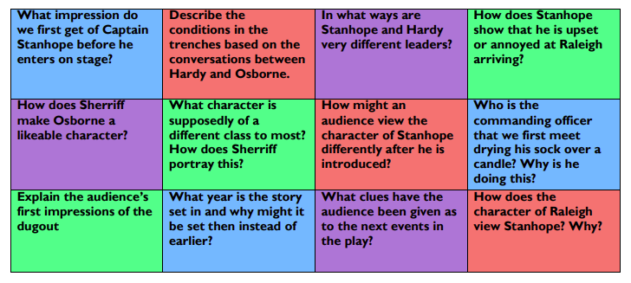

Task 6 – 4 hours

As well as critical books about specific writers, there are also a wide range of books available about literature more generally. The opening pages of all the books listed below are available online via Amazon’s ‘Look Inside’ feature.

Have a scan through and choose one from each category.
Select a couple of quotations from the pages and explain why they interest you.

On Novels:
John Mullan: How Novels Work
Daivd Lodge: The Art of Fiction
Francine Prose: Reading Like a Writer

On Poetry:

James Fenton: An Introduction to English Poetry
Ruth Padel: The Poem and the Journey
Mark Yakich: Poetry – A Survivor’s Guide

On Shakespeare:

Bill Bryson: Shakespeare – The World as a Stage
Emma Smith: This is Shakespeare

On Drama:

David Edgar: How Plays Work
Richard Eyre: Interviews with Theatre People
Steve Waters: The Secret Life of Plays

On English in general:

Robert Eaglestone: Doing English

__________

Spend an hour exploring each different section of the website that will help prepare you for other elements of this course:

https://www.bl.uk/shakespeare

https://www.bl.uk/restoration-18th-century-literature

https://www.bl.uk/romantics-and-victorians

https://www.bl.uk/20th-century-literature

Additional tasks:

Challenge yourself – look at lists of 100 best novels of 21st century. Make yourself a reading list, buy the book or borrow from library, let us know what you are reading and your thoughts on the novel. Enjoy!

Any questions, please email:

Cfarrell-carver@waseleyhills.crst.org.uk

