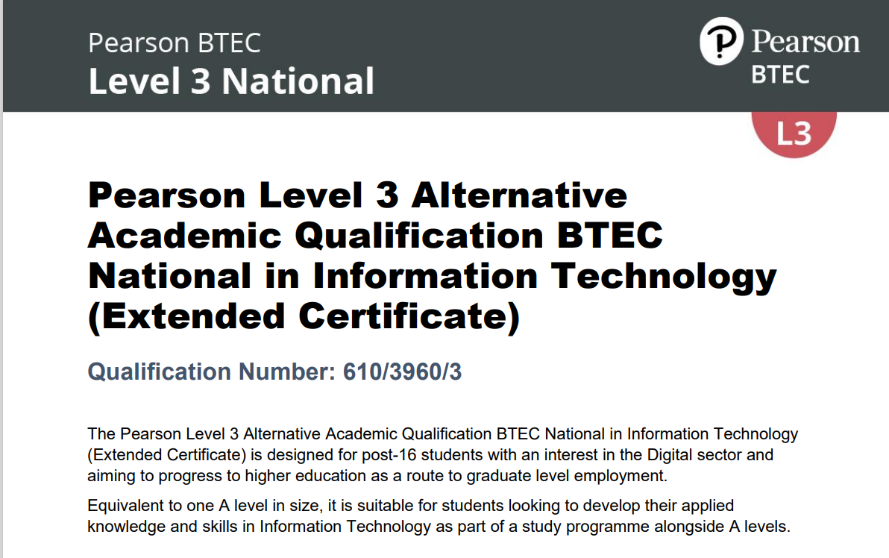

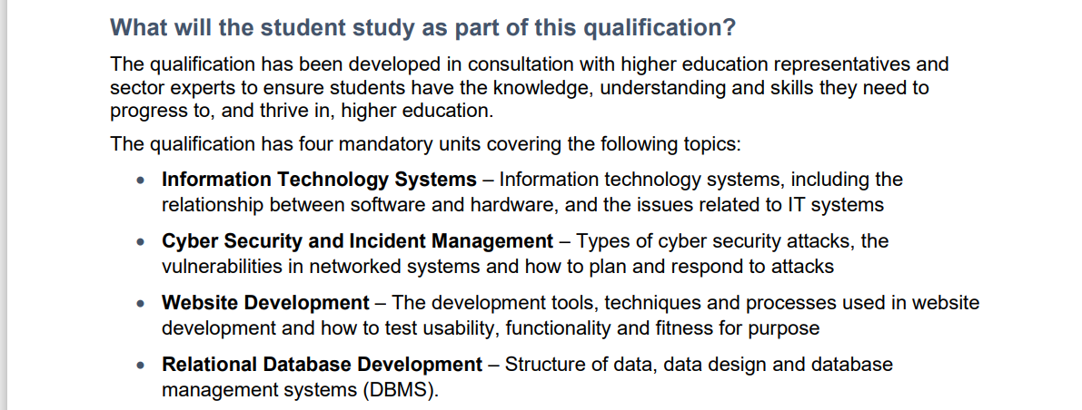

Unit 1: Information Technology Systems – externally assessed (90 marks, 2 hrs)
Unit 2: Cyber Security and Incident Management – externally assessed (90 marks, 2 hr 15 mins)
Unit 3:Website Development– internally assessed (15 hrs, PASB)
Unit 4: Relational Database Development – internally assessed (15 hrs, PASB)



