Year 7 ICT and Computing

Name and surname……………………………………………
Group/teacher…………………………………………………….

3. Programming (Python)
Grade:

- Network
Grade:

- Impact of technology
Grade:

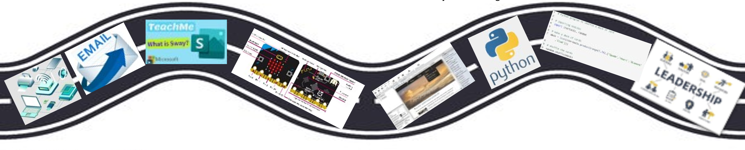
6. Project management
Grade:

4. Data Modelling
Grade:

5. Using Media Grade:

Extra curriculum – Online Safety assembly, Workshop from the technicians (Network), design an app and Interhouse competition (Using Media)

Year 8 ICT and Computing

Name and surname……………………………………………
Group/teacher…………………………………………………….

- Computer Systems
Grade:

- Programming (Python)
Grade:

- 2D Graphical software (Inkscape)
Grade:

- Developing for web (HTML)
Grade:

6. Project management
Grade:

- Representations (Binary and Denary)
Grade:

Extra curriculum – Online Safety assembly (WEST MERCIA), Workshop from the technicians (assembling computer), design a website - competition, Interhouse competition (Representations)

Year 9 ICT and Computing

Name and surname……………………………………………
Group/teacher…………………………………………………….

- Cybersecurity
Grade:

- Programming (Python)
Grade:

- 3D Graphical (Blender)
Grade:

4. Representations (Binary to Denary)
Grade:

- Project Management
Grade:

5. Data Science (data collection and spreadsheet)
Grade:

Extra curriculum – KS3 microbit, Cyber security workshop and Online Safety assembly (WEST MERCIA), representation - inter-house competition

Name and surname……………………………………………
Group/teacher…………………………………………………….
Years 10 and 11 BTEC Levels 1 and 2 DIT

Component 1 revision

Component 1_ PSA (Pearsons Sample Assignment) Grade:

Apr – July (Component 3 examination practice)
Grade:

Component 3 – study
Mini assessments

Years 12 and 13 BTEC Level 3 Information Technology, AAQ

Name and surname……………………………………………
Group/teacher…………………………………………………….

Unit 3: Website Development
Grade:

Unit 1: Information Technology Systems
Grade:

Unit 4: Relational Database Development
Grade:

Unit 2: Cyber Security and Incident
Grade:

