Dear Parents and Carers, 15th September 2023

I am writing to express my gratitude for your continued support and to share some positive feedback regarding the first full week back for this academic year. All students were involved in the Waseley Team Building Day on Monday in which students had to complete outdoor team-based activities, survive on a desert island and complete a virtual escape room. This was a great way for staff to build strong working relationships with students and the feedback from students has been positive. We have also had Elevate education in this week working with students on revision skills and effective note taking. I am pleased to report that students have had an excellent attitude and the engagement of students has been well received by staff running these sessions. The Year 10-13 students have also got access to a free parental support session Thursday 21st September 5:30pm with more details to follow. I would also like to congratulate Years 8-13 for making our new Year 7 students feel welcomed and part of the school.
Please could I ask for your support in reminding students to wear the correct uniform, including branded PE Kit. This consists of Waseley Hills school logo hoody, T-shirt, navy shorts/skorts with school logo and no hot pant type shorts - they must reach to just above the knee. Alternative logo or branded fashion items are not permitted. If you do have any of these items in good condition that no longer fit your child, please consider donating them to the school for us to distribute to students and families that need them. Any donations can be dropped at the school Reception.
I would also like to ask for your support in ensuring that students understand their duty to the community on entry and exit from the school. We expect them to uphold the exceptional standards that they do within the building to and from school and this includes their uniform and conduct. It is important that our community feel safe and see the brilliance of our students and it has been pleasing to see so many being polite to members of the public in and around the school gates over the past two weeks.

Finally, we look forward to the fundraising day in memory of Nicola Hurlbutt on Sunday 17th September at Waseley and hope that this raises a good amount of money for the Meningitis Research Foundation.
Thank you for your continued support and we hope you have a lovely weekend.

Yours sincerely,
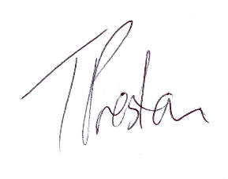
Tom Preston
Head of School

