Dear parent/carer, 25th October 2024
Re: Personal Development at Waseley Hills High School

We believe that promoting the health and wellbeing of our pupils is an important part of their overall education. We do this through our personal, social, health and emotional (PSHE) curriculum. PSHE covers many topics including all kinds of relationships, physical/emotional health and the skills needed to live in the wider world. The aim of our PSHE curriculum is to help pupils make safe and informed decisions during their school years and beyond.

Relationships, sex and health education (RSHE) is the statutory element of our PSHE curriculum, it is statutory for all schools in England teach personal, social, health and emotional (PSHE) and relationships, sex and health education (RSHE) in secondary schools. We will be teaching lessons about PSHE/RSHE as part of our Weekly timetabled PSHE lessons and during culture time in respective forms. This will include topics such as naming body parts; families; online safety; puberty; babies and birth; relationships and communication skills; pregnancy; contraceptives; prevention of HIV/AIDS and other sexually transmitted diseases; prevention of sexual abuse; FGM; body image; sexting and social media; pornography; consent]. During these lessons, pupils will be able to ask questions, which will be answered factually in an age-appropriate manner. Each pupil's privacy will be respected, and no one will be asked to reveal personal information. PSHE/RSHE is a carefully planned curriculum and is there to ensure our pupils can navigate the world around them safely. An un-informed child is often a child left vulnerable, and we want to empower our pupils here at Waseley Hills High School, Parents and carers are the most important educators of children and young people in personal issues and many welcome the support that school can offer to supplement their home teaching. Please refer to the curriculum map on the website which details specific topics your child will be taught during each term.

PSHE/RSHE is a statutory subject and although parents/carers can withdraw their child from the sex education element, we want to assure parents that our curriculum is taught in an age-appropriate manner and provides pupils with the time to ask questions in a safe environment and ultimately receive factual information, rather than hearing content second hand or via online platforms. In the 21st century pupils are exposed to so many of the incorrect messages about their bodies, relationships, and expectations. The prevalence of sexual images in social and other media make it important that all young people have a place to discuss pressures, check facts, dispel myths and ultimately feel safe.

We will be teaching RSHE element from our PSHE curriculum during the Autumn Term 2024-January 2025), If you have any queries about the content of the programme or resources used, please do not hesitate in contacting me at school. If you would like to withdraw your child from RSHE lessons, please complete the attached form. All materials used are available for you to browse through should you so wish. You may find that your child starts asking questions about the topic at home, or you might want to take the opportunity to talk to your child about issues before the work is covered in school.

Yours sincerely,

Mrs E Meredith
DSL Vice Principal and Personal Development Lead

Values and Aims
Students will learn the significance of stable relationships as key building blocks of community and society. Care will be taken to ensure that there is no stigmatisation of young people based on their home circumstances ensuring inclusivity and sensitivity for all learners and their backgrounds. The CRST schools across the Trust serve a wide variety of communities and cultures and recognise the different beliefs and needs of each individual student cohort.

The aims of the RSHE programme of study are to enable students to: -
- avoid being exploited or exploiting others or being pressured into unwanted sexual behaviors.
- be prepared for puberty and adulthood; -
- challenge stereotyping and prejudice in order to encourage mutual respect.
- communicate effectively by developing knowledge of appropriate terminology and ensuring knowledge and information is factually accurate and current.
- develop and use communication and assertiveness skills to cope with the influences of their peers and the media; -
- develop knowledge of when and how to access support and guidance.
- develop positive values and a moral framework that will 1) guide their decisions, judgements, and behaviour 2) give them the confidence and self-esteem to value themselves and others 3) give them respect for individual conscience and the skills to judge what kind of relationship they want.
- know how the law applies to sexual relationships in order to safeguard themselves; - understand their personal feelings and behaviour so they can lead fulfilling and enjoyable lives.
- make safe choices when using technology, such as social media platforms.
- make well-informed, positive choices to support their own health and mental wellbeing.
- understand the consequences of their actions and behave responsibly within relationships.
For further information on each strand of the topics visit ‘Relationships and sex education (RSE) and health education’ at www.gov.uk/government/publications/relationships-education-relationships-and-sex-education-rse-and-health-education

Misunderstandings about RHE/ RSHE

Schools have an important role to play in RHE/RSHE.

There is sometimes concern that RSE in school might promote sexual activity or cause confusion about an individual’s sexuality. The research on quality RSE points to a more positive outlook: 87 programmes from many countries were examined by UNESCO in 2009. This led to the conclusion that if RSE has an effect it is a positive one: ‘sexuality education can lead to later and more responsible sexual behaviour or may have no discernible impact on sexual behaviour’.

Secretary of State Foreword 2020:
‘Today’s children and young people are growing up in an increasingly complex world and living their lives seamlessly on and offline. This presents many positive and exciting opportunities, but also challenges and risks. In this environment, children and young people need to know how to be safe and healthy, and how to manage their academic, personal and social lives in a positive way’.
(See www.gov.uk/government/publications/relationships-education-relationships-and-sex-education-rse-and-health-education)
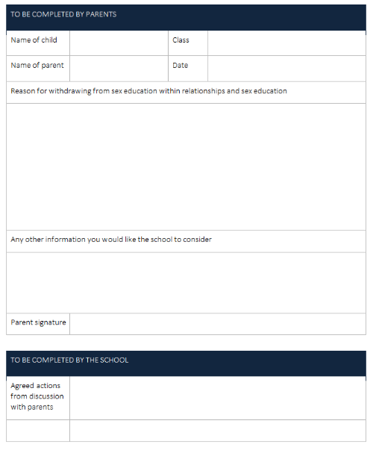
Parents have the right to withdraw their children from the non-statutory components of sex education but not Health or Relationships within RSE up to and until 3 terms before the child turns 16. After this point, if the child wishes to receive sex education rather than being withdrawn, the school will arrange this.

- Requests for withdrawal should be put in writing using the form attached and addressed to the headteacher.
- A copy of withdrawal requests will be placed in the pupil’s educational and safeguarding record. The Head of Year will discuss the request with parents and take appropriate action.
- Alternative work will be given to pupils who are withdrawn from sex education

