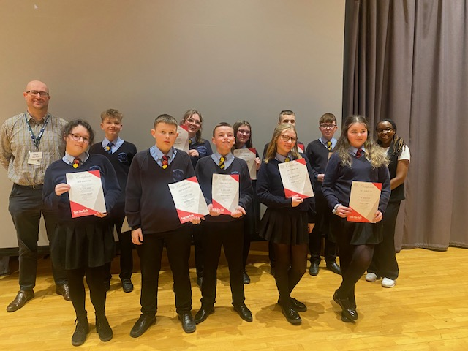
Eye Spy Enrichment at Waseley
Talk the Talk workshop to develop confidence and character to work effectively as Social Action Student Leaders

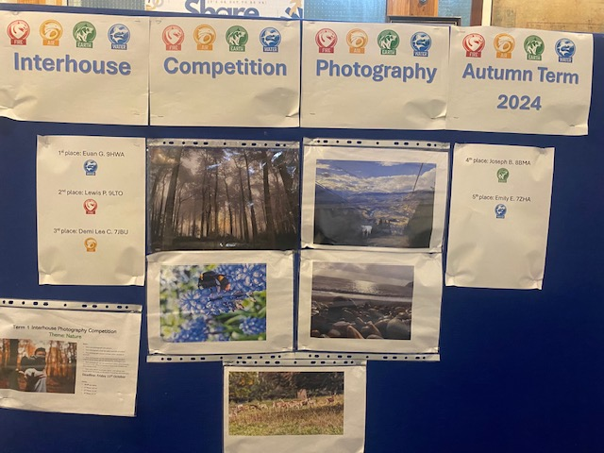

Photography Competition

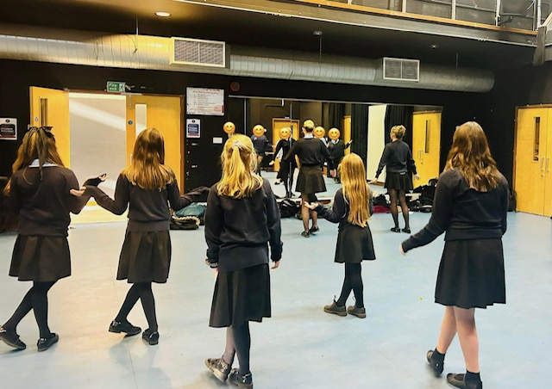
Matilda the Musical Rehearsals led by our Performing Arts Student Leaders

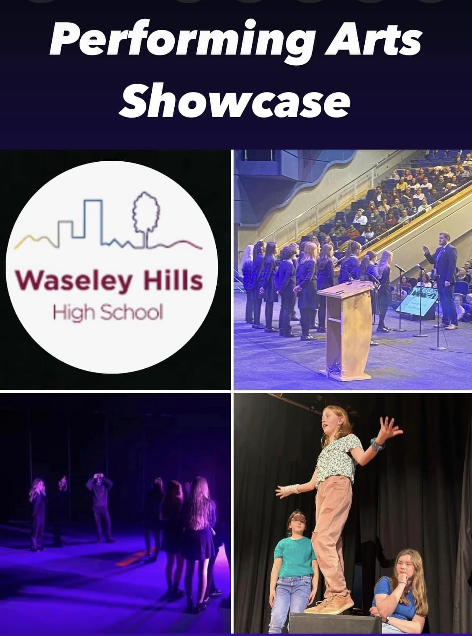
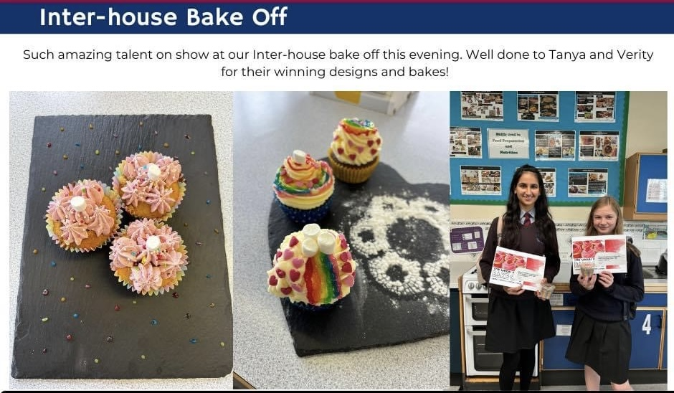
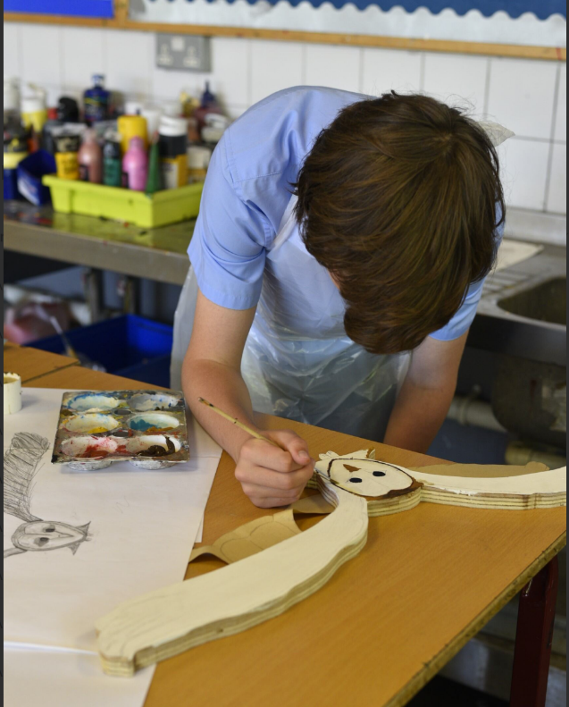
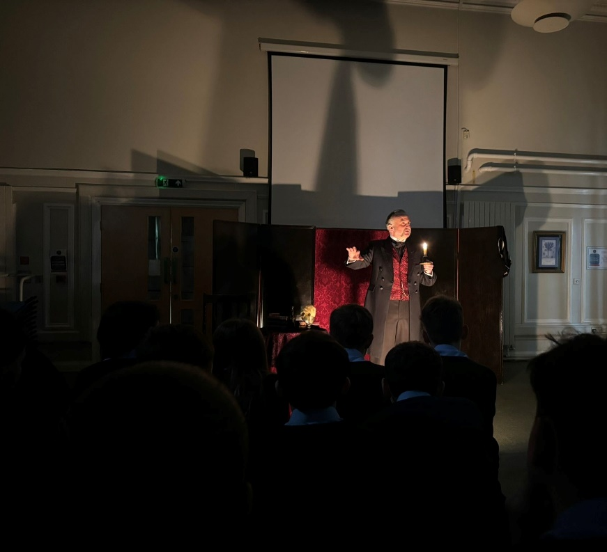
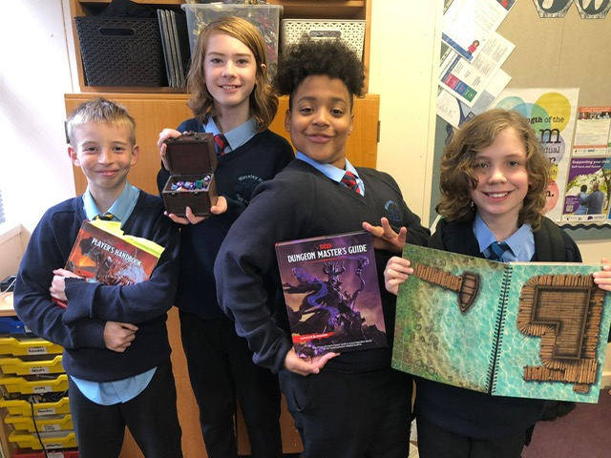
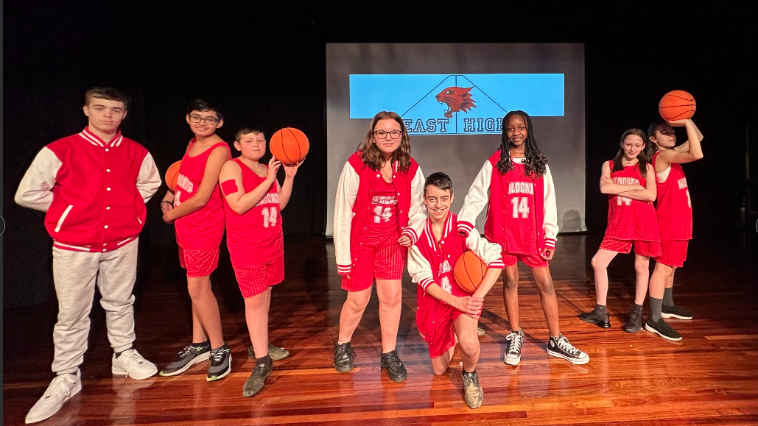
Community Art Project
Y9 Live Theatre Performance Experience
Dungeons and Dragons Club
Show week for High School Musical!

