Dear Parents and Carers 8th December 2023

It has been another fabulous week at Waseley. This morning saw a wonderful collection of Christmas hampers that demonstrated just how generous our students and community are. They will make the world of difference to families over the Christmas period. We also raised over £200 for Save the Children during our Christmas jumper day on Thursday this week. The students were excellent in their conduct and enthusiasm throughout the day and we are eagerly looking forward to our charity week starting Monday 18th December. A reminder that a purchase of a wrist band includes non-uniform day on Friday 22nd December and will go towards our ambitious aim of raising £1000 over the week.

The Year 11s have had a fantastic trip to Aston University and Birmingham City University this week. The students have returned inspired and motivated to raise their aspirations and this forms part of our successful first round of sixth form applications. We have seen a large number of students applying for sixth form this year and also had confirmation that the number of applications for Year 7 is at its highest point in a number of years.

We have also welcomed Elevate Education today for a study skills session for Year 10 and Year 12 students. This will provide the students high quality guidance on how to revise effectively and prepare for their studies moving forwards.

Ofsted visited us on Wednesday of this week to conduct a section 8 monitoring inspection. The Inspection was led by HMI Stuart Clarkson. For these monitoring visits Ofsted don't ask for Parent View in the same way they would for a full, section 5, 2-day inspection. We did however share your overwhelmingly positive feedback from the survey carried out a few weeks earlier. As part of the inspection, the day was spent forensically scouring through lessons, social time and meetings with pupils, staff and leaders. Though we cannot share the outcome of this with you until our letter from HMI Clarkson is published in January, we are very excited to share it with you once it arrives. This was a watershed moment for the school in its ambition to be the excellent educational provider for such a deserving community.

A reminder that Year 11 Parents Evening takes place next Thursday 14th December 4pm-6:30pm and that bookings are taking place through School Cloud. We will be providing mock performance updates, guidance on revision and the opportunity to pick up printed exam papers.

We also look forward to the Christmas carol concert at St. Chads on Monday 11th December. The start time has been altered to 5:45pm. We are hosting our own Christmas concert at Waseley on Tuesday 19th December which starts at 6pm-All welcome!

Have a wonderful weekend and thank you for your continued support.
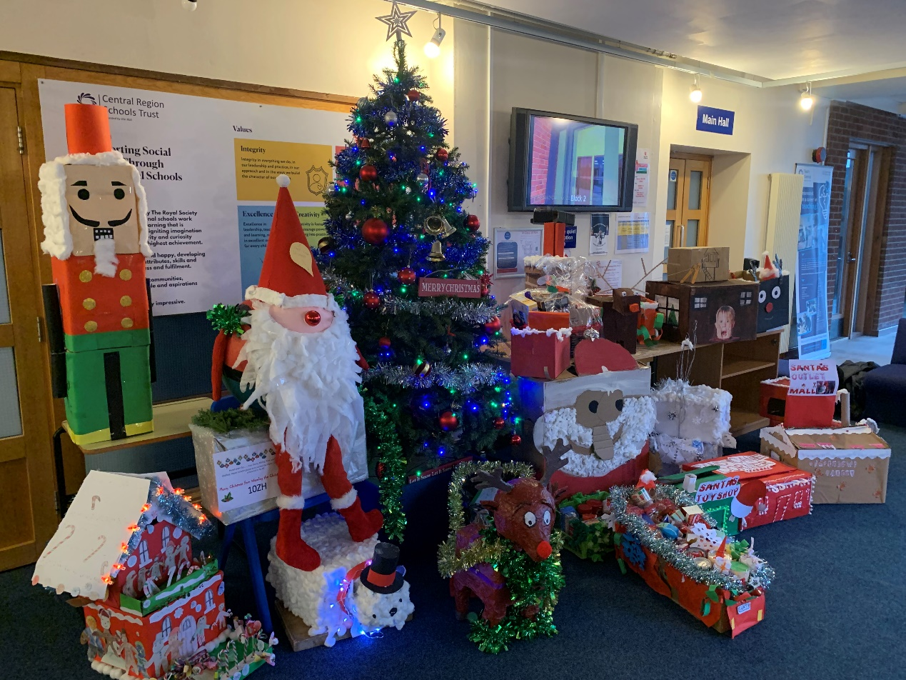
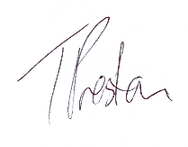
Yours sincerely
Mr T Preston

Head of School


